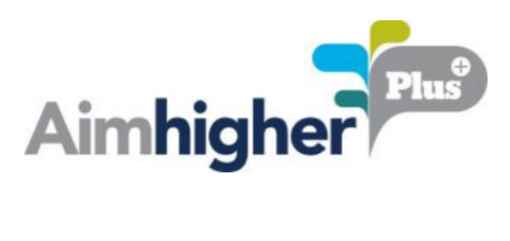
POETRY COMPETITION

Notification of winners:

We will notify the winners and runners up via email copying in the relevant school coordinator. We will announce all winners via the Aimhigher Newsletter.

Promoting your poetry

By submitting your poetry into this competition you are agreeing for your work to be shared by Aimhigher West Midlands and their partner universities (Aston University, Birmingham City University, Newman University, University College Birmingham, University of Birmingham and University of Worcester) on a number of channels, including social media, e-bulletins and website.

Why are we asking you to provide this data?

We are asking for your name, school / college name and year group as our funders (the Office for Students) require us to track your engagement within Aimhigher activities. This data will be shared with Aimhigher partners and commissioned services (including but not limited to university partners, colleges and schools) and our funders (the Office for Students). This data helps Aimhigher to monitor and evaluate the effectiveness of our activities. More information about how we process your data is available on the Aimhigher website: http://aimhigherwm.ac.uk/about-us/gdpr/

How will the artwork be judged?

Our chosen judge will bring a unique perspective and opinion to the judging, this will cultivate a varied selection of work that showcases the very best of the entrants.

Poetry of an inappropriate or offensive subject matter will be removed from the competition.
All work must be your own work. This means we will not accept poetry that directly copies other people’s work (this does not include artistic interpretations).

